24K-0682 PF Assignment 3

Question 1:

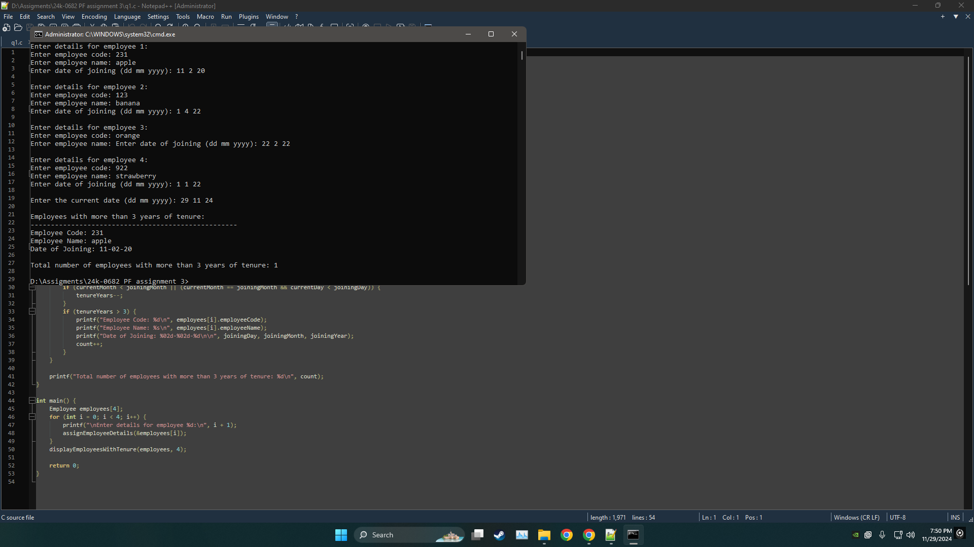  
Question 2:

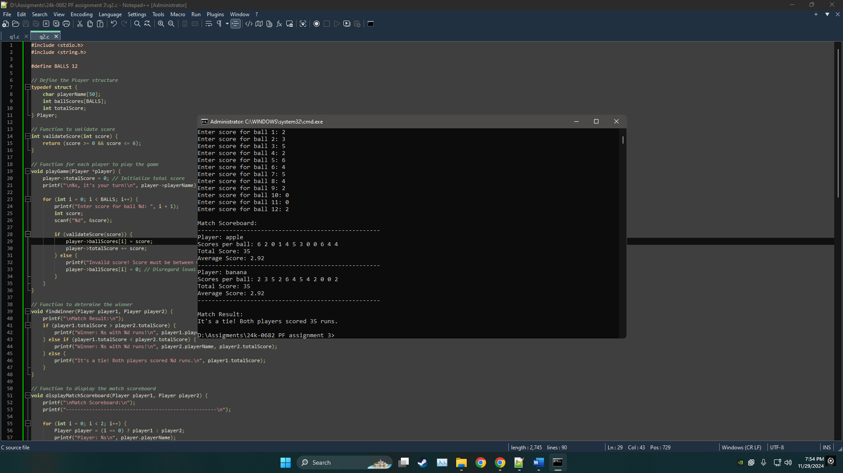

Question 3:

Question 4:

Question 5:

Question 6:

Question 7:

